Steps:
1. I open up the picture in Photoshop and shrink it's size so it's more....manageable. So, Image >>Image Size and use these settings:
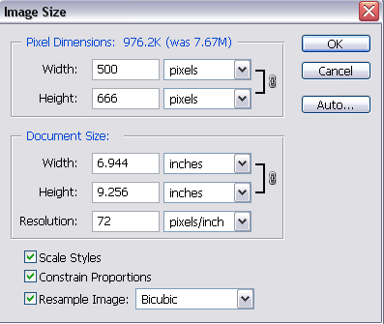
It's just more manageable for me. It's completely optional. Moving on.
2. Type your text. I have used Carnivale Freakshow as my font, which can be downloaded at www.dafont.com, the size is at 105 and it's white.
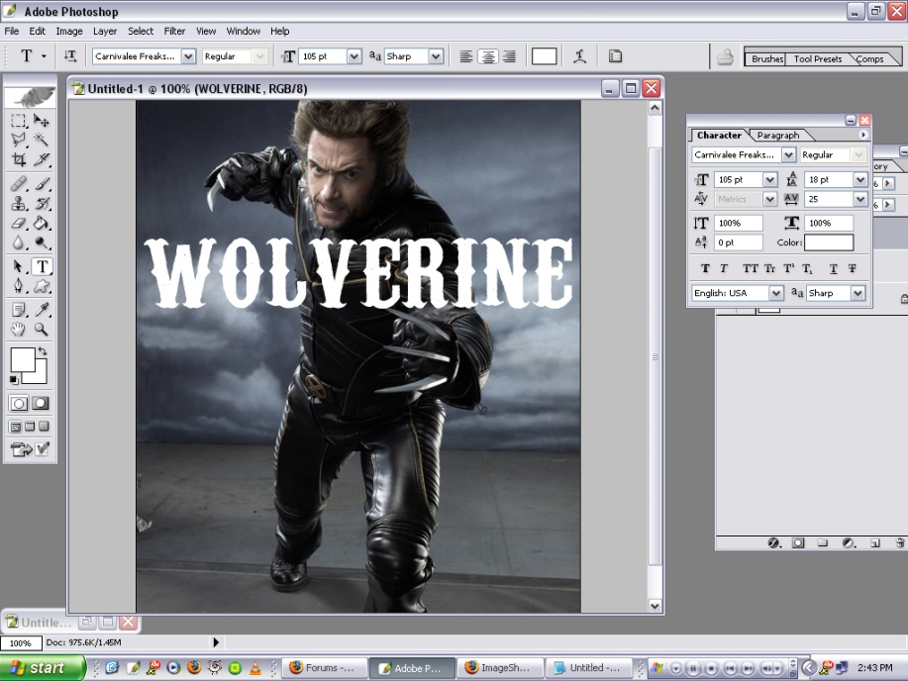
(thumbbed)
3. Now, this is the easy part. Right click on the layer on the layers pallette, and choose "Rasterize Layer" ( OR Rasterize TEXT), which takes it's font-ness away from it and now it's just shapes.
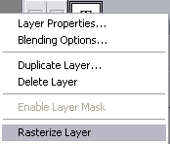
4. Lower the text/shape layer to like 30% opacity. Now you can see through the text.
5. Grab your eraser and just erase the parts of the words that are over Hugh. I have chosen a 27pt Hard edged eraser for the job. Just keep erasing. You may want to zoom in to see the text better, and you can do that by going Window >> Zoom In (or hold cntrl and the + sign).
6. Now, zoom out and then raise the opacity of the shape layer back up to 100 and voila! 